# **C-ATFM Weekly Report (25thApril-1stMay’22)**

1. **IFR Traffic at Indian Airports/Airspace:**
2. **Top Ten Busiest Indian City pairs this week:**
3. **Flight Operations – Airline wise:**
4. **Air Traffic Movement at 6 Major Airports:**

*Note: Recently it is observed that SKYFLOW system has been missing FPL and associated ATS messages due to AFTN link issues. The actual movement at Airports is more than the movements captured by SKYFLOW.*

1. **International Traffic Flow at Indian Airports:**

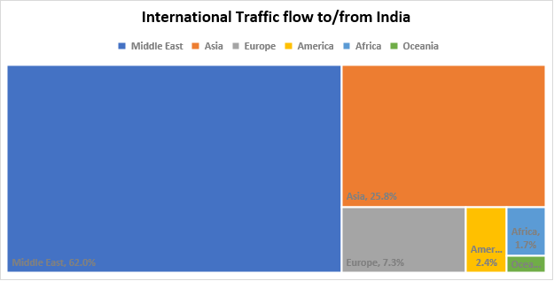

1. **Other Important Information:**

* SKYFLOW System is not receiving meteorological images from Kolkata, Chennai and Srinagar.
* ADEXP messages are not being received from Jaipur, Ahmedabad, Trivandrum and Chennai Airport CDM.